**LOA**

Active Employee

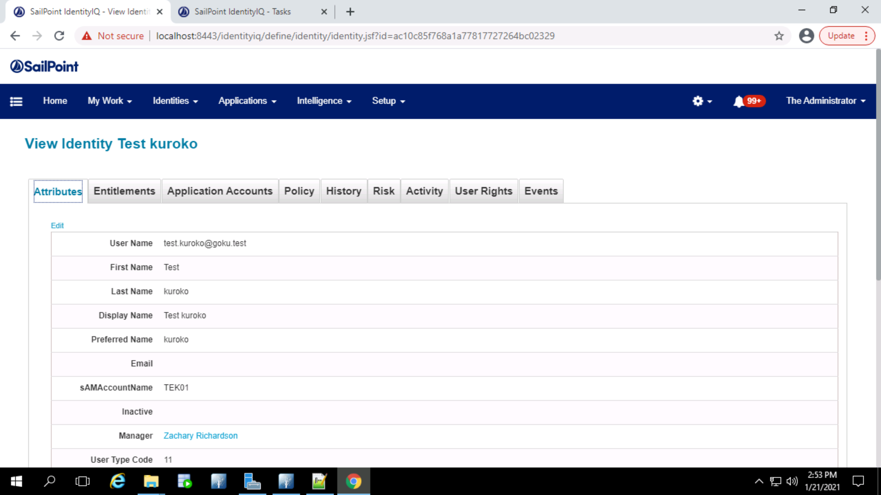

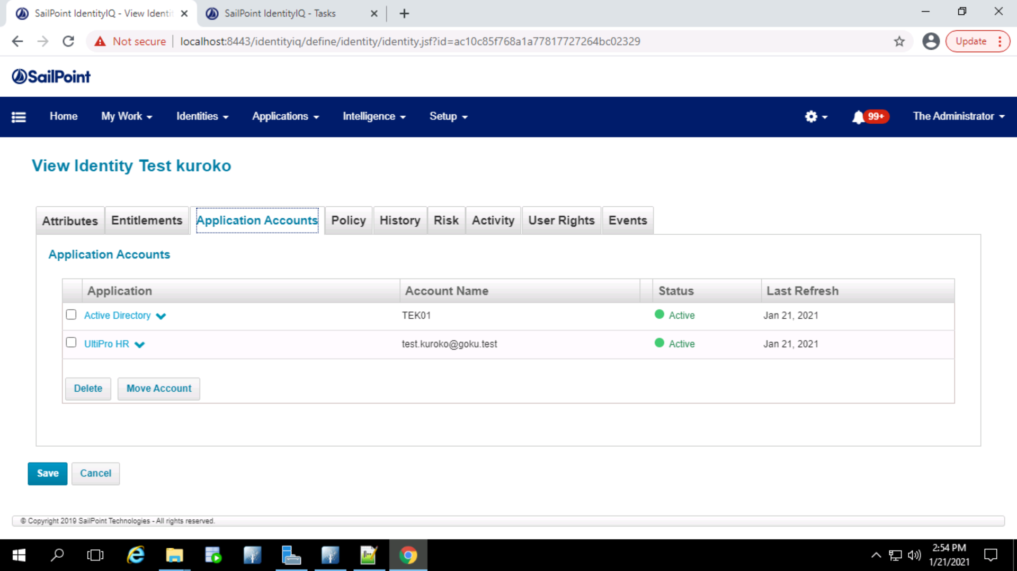

Ultipro file sends ‘L’ (Employee_Record_Type) status for the employee and LOA event gets triggered

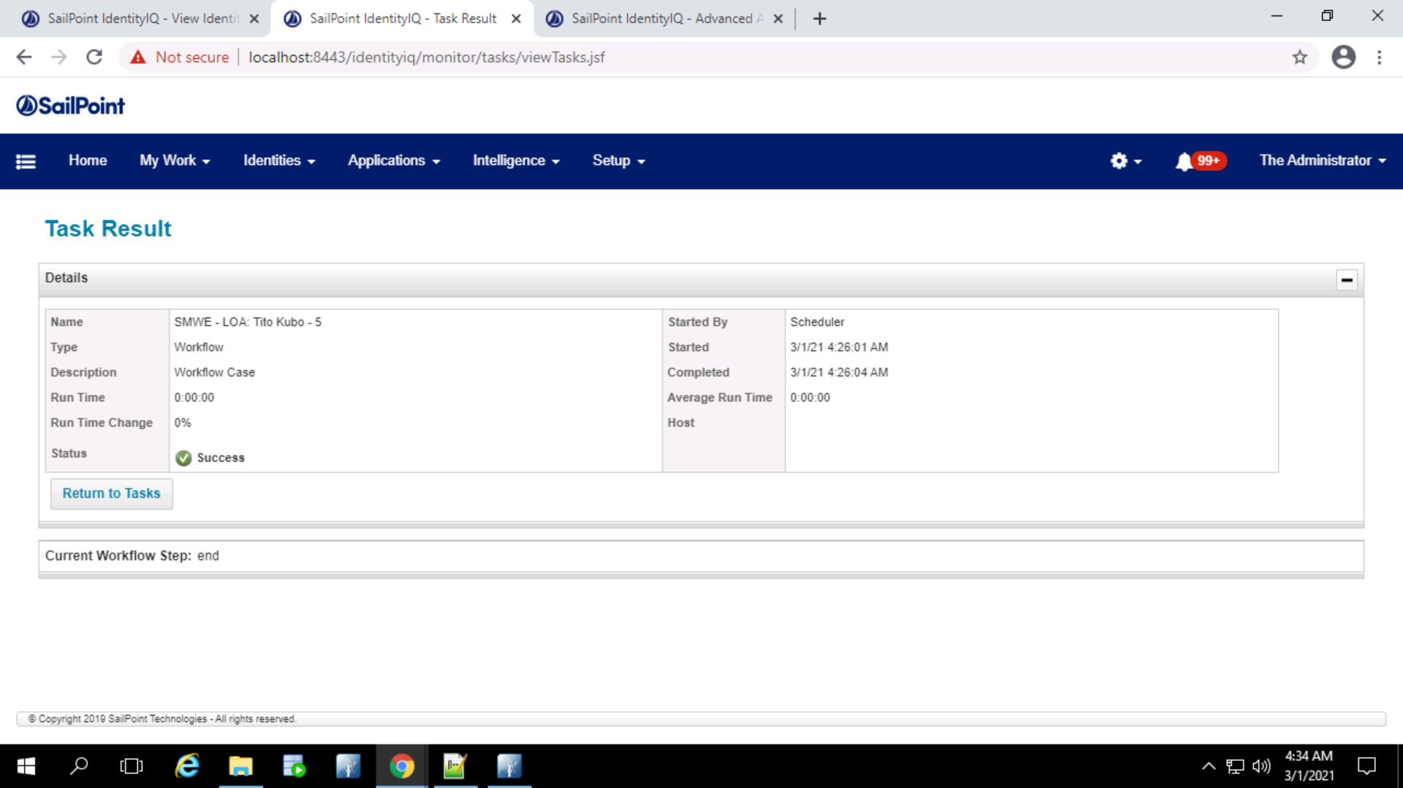

The AD account will remain active in case of LOA event.

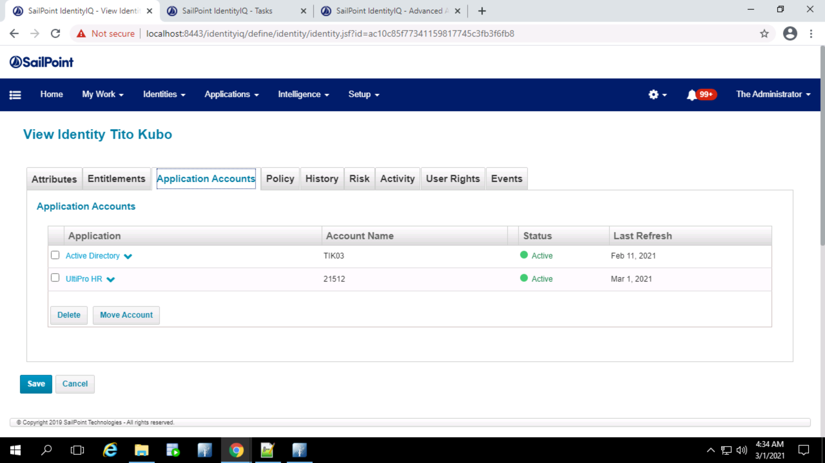

The comment attribute in AD is set as ‘The user is in LOA status’

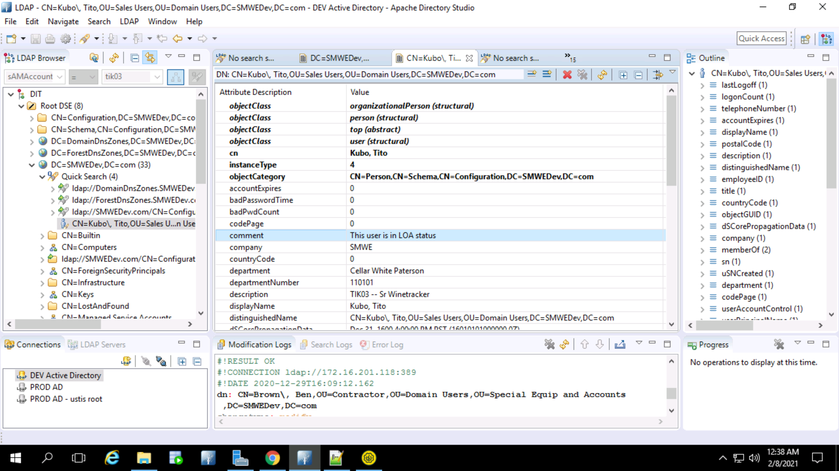

A mailbox retention policy has been set to true when the LOA is triggered for this particular identity.

After 90 Days (if the Ultipro user account status is still ‘L’) email will be triggered to the ‘Carolyn Calderon’ to take an action on the user if there is no action taken till 90 days.



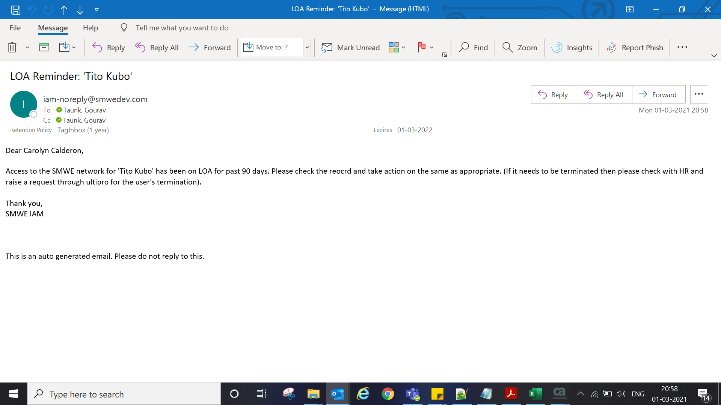

When the LOA turns back to active the mailbox retention policy will be set to False.

**HOLD**

Active Identity

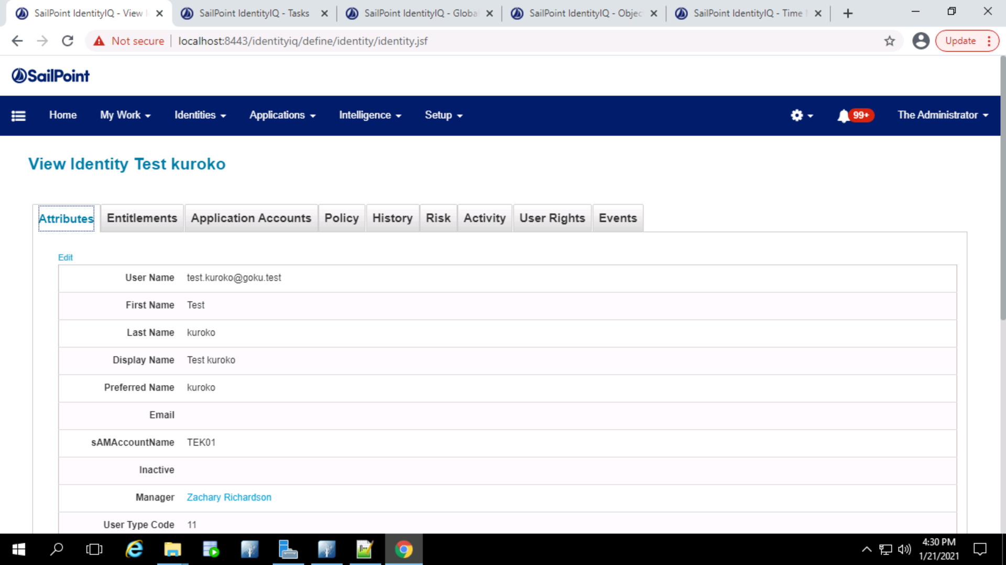

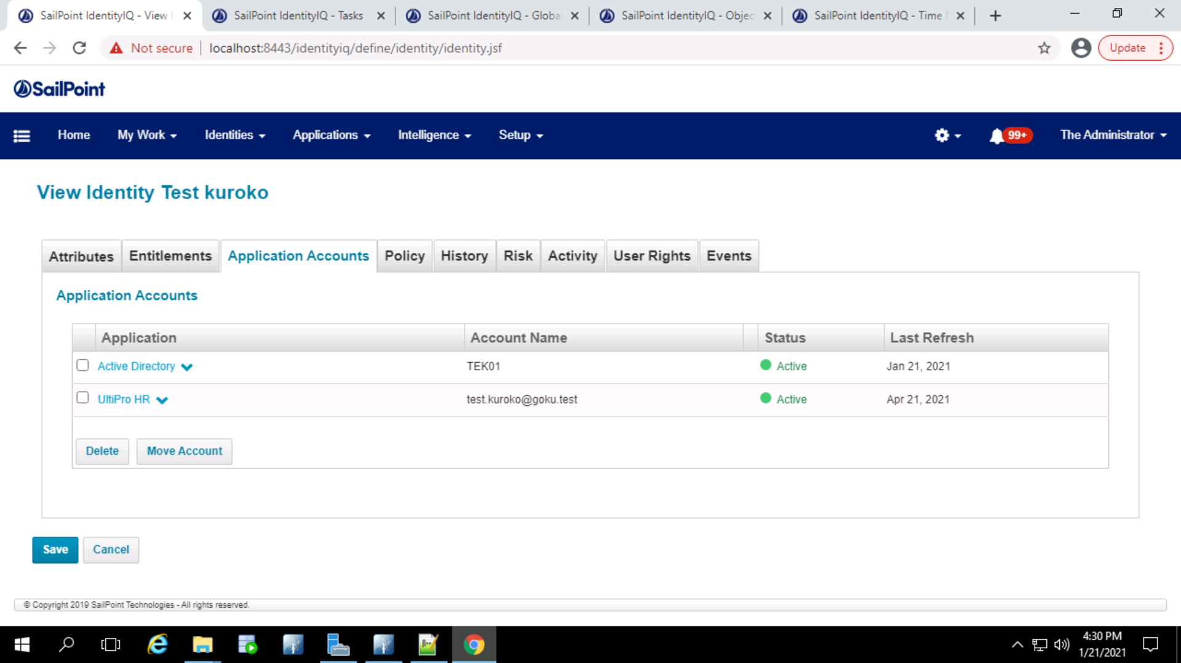

Ultipro file sends the status as ‘H’ (Employee_Record_Type) and Hold is triggered

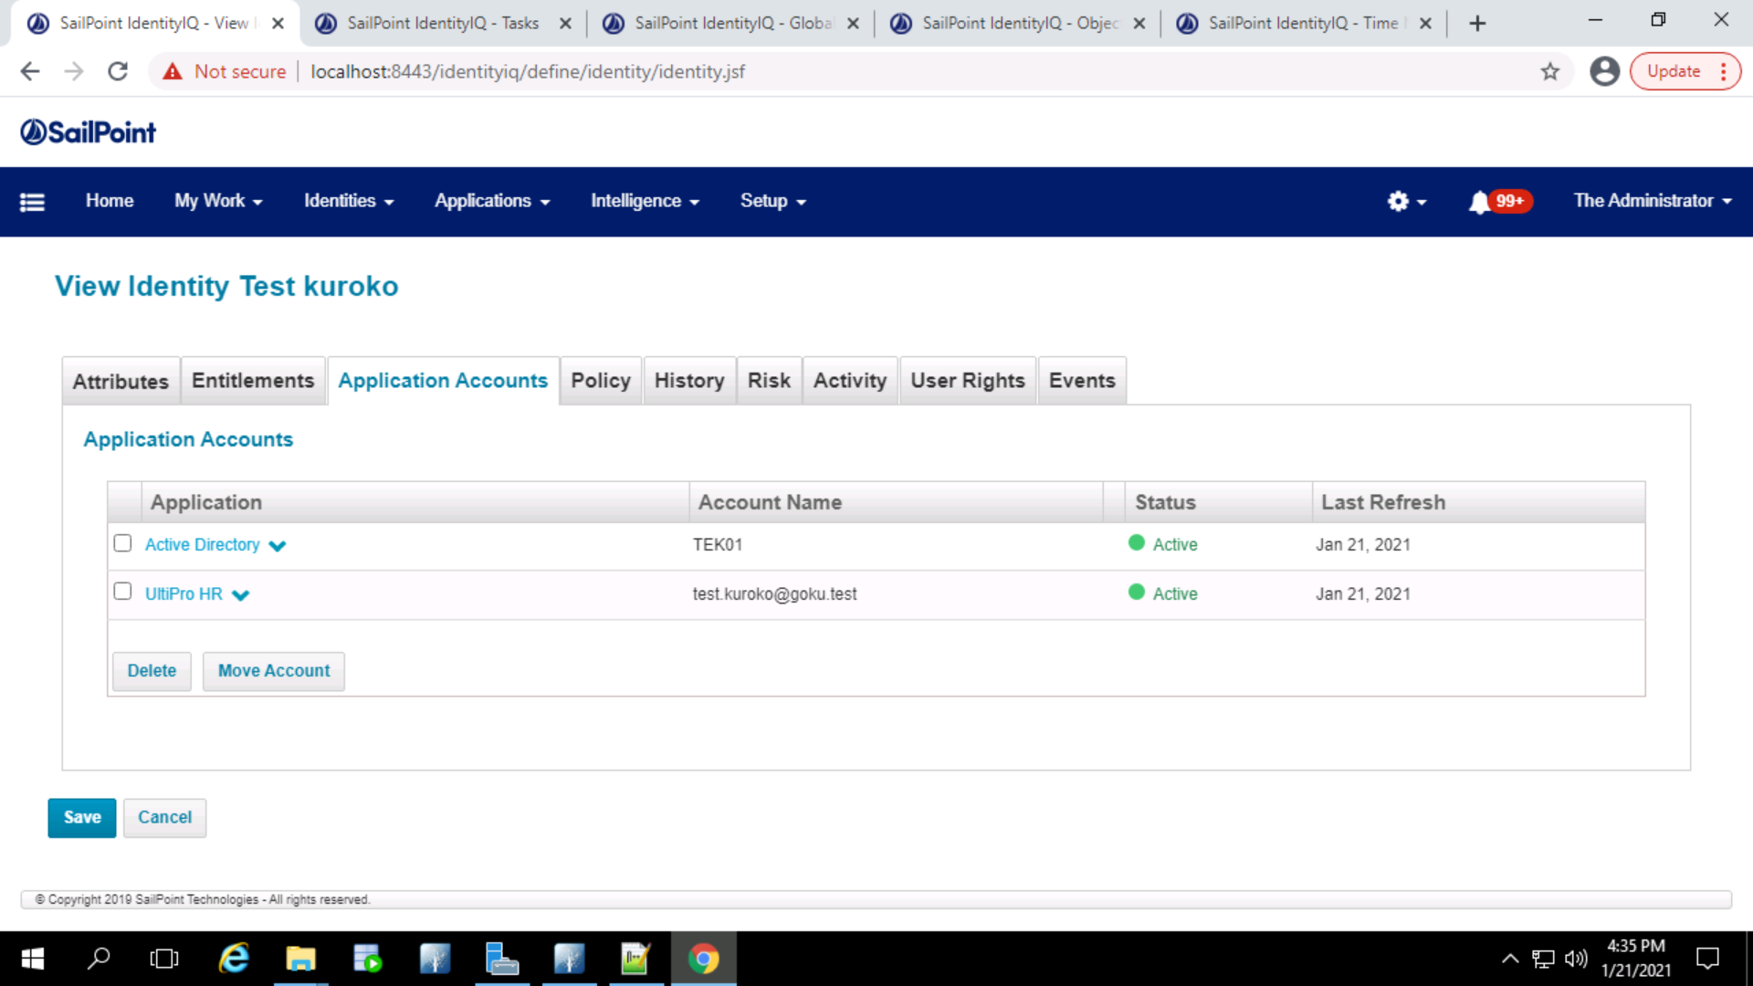

The comment attribute in AD is set as ‘The user is in HOLD status’

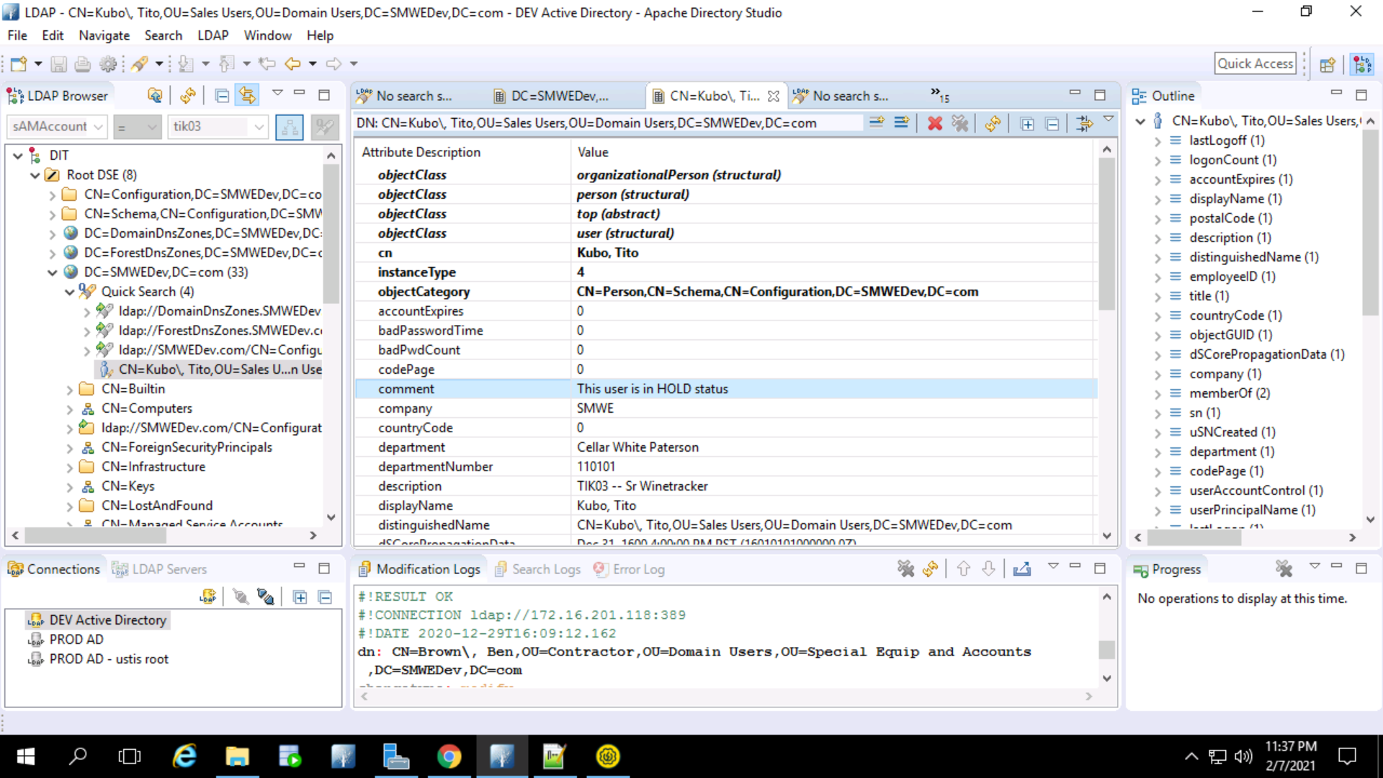

An email to the manager will be triggered with the new password

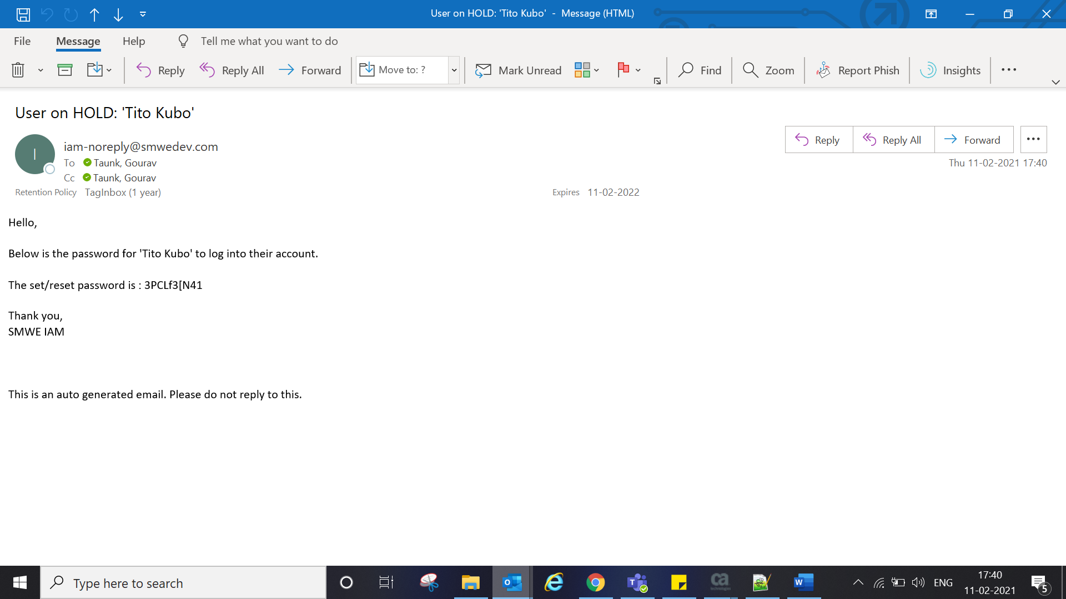



And a 90-day email trigger task will be created which will be triggered if no action is taken upon till then.

After 90 days the following email gets triggered to the manager.

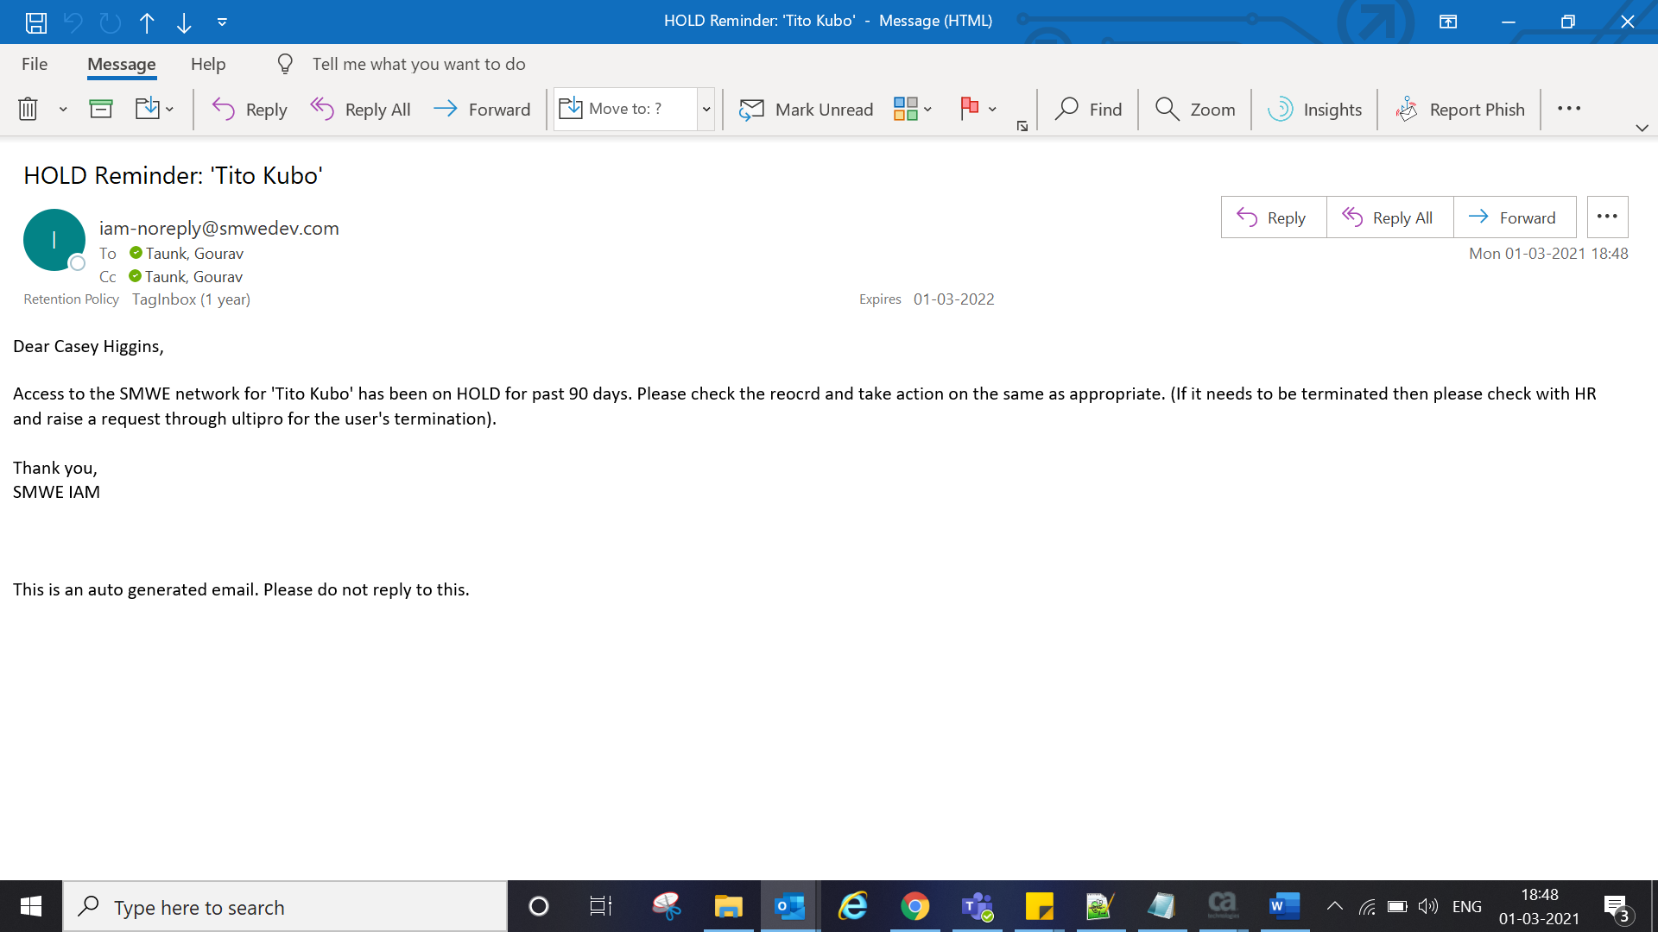



Hold -> Active

Employee present in ultipro in HOLD ‘H’ status

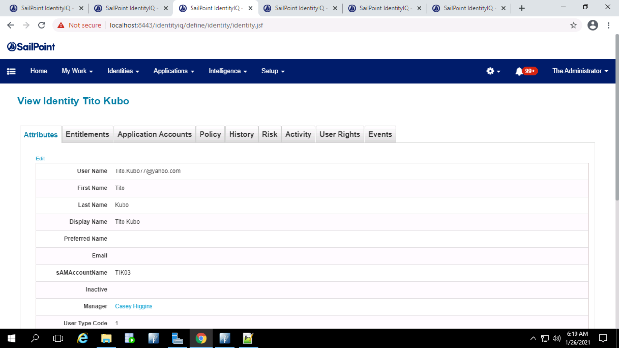

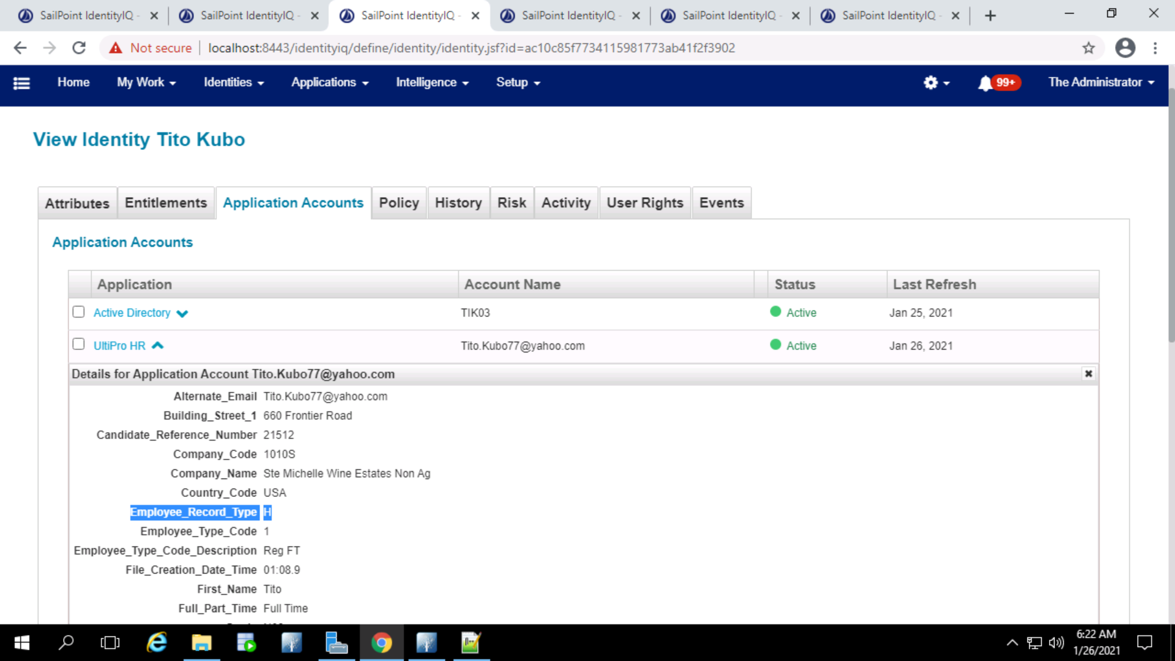

When the ultipro ‘Employee_Record_Type’ changes from ‘H’ (Furlough) to ‘A’ (Active), rehire gets triggered.

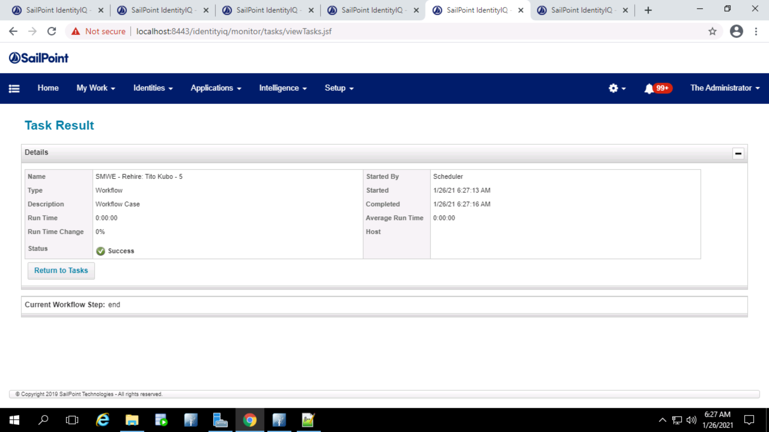

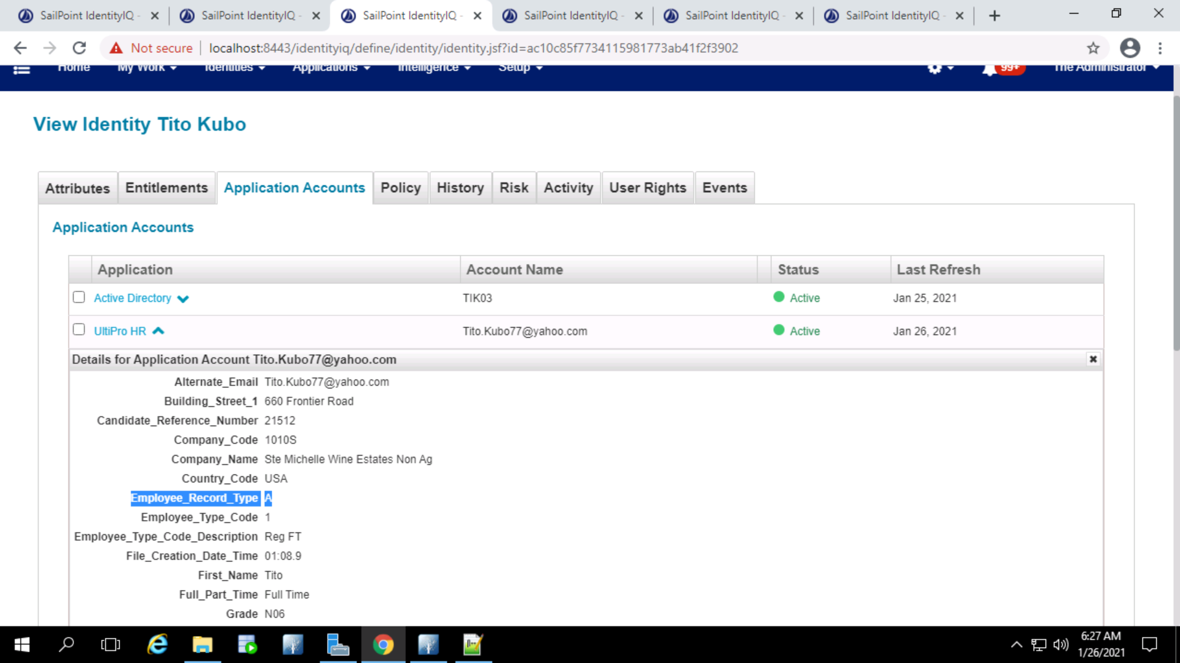

Rehire sends one email to the manager of the user with the password for the user in the email.

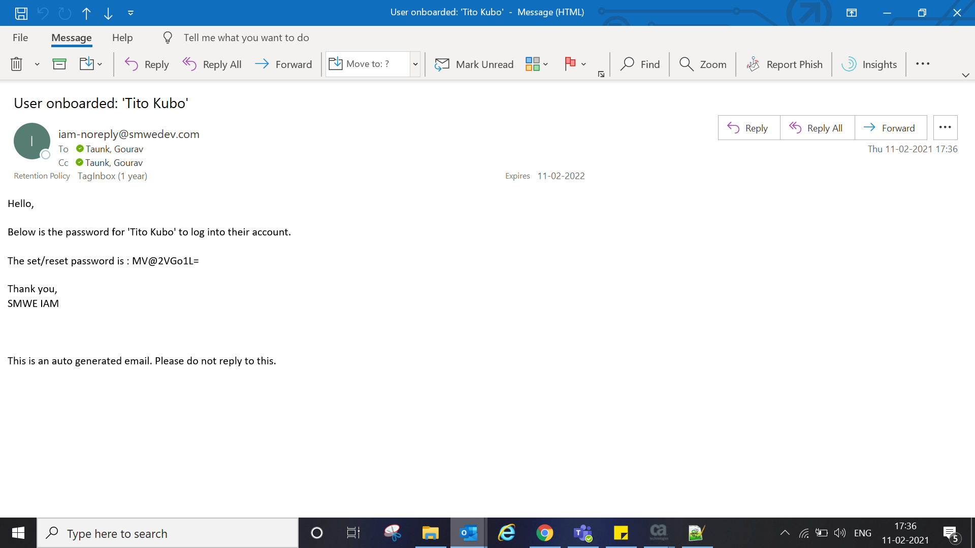



**Furlough**

Active record present in sailpoint

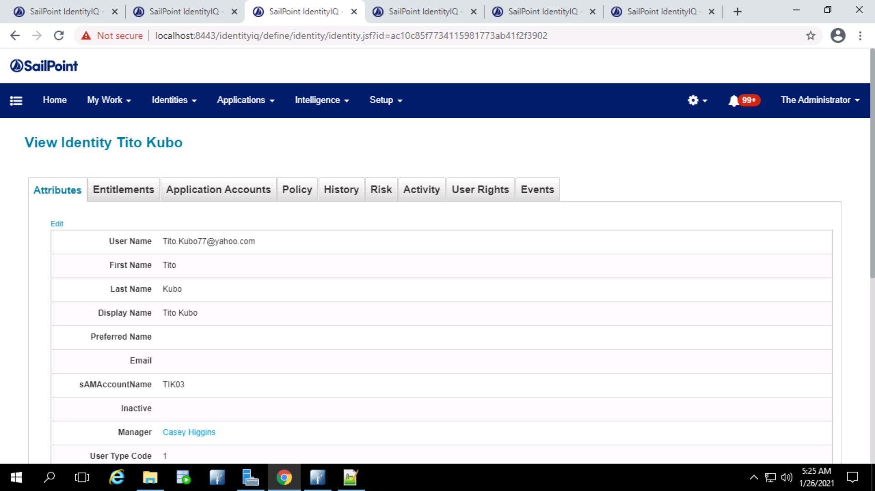

Ultipro file sends the status as ‘F’ (Employee_Record_Type) and Furlough is triggered

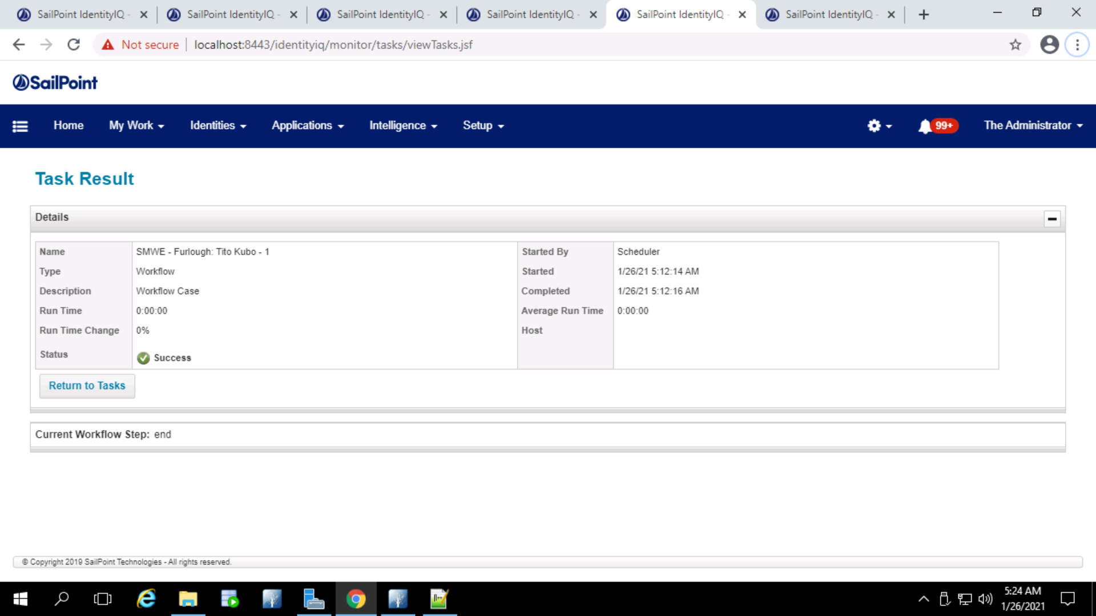

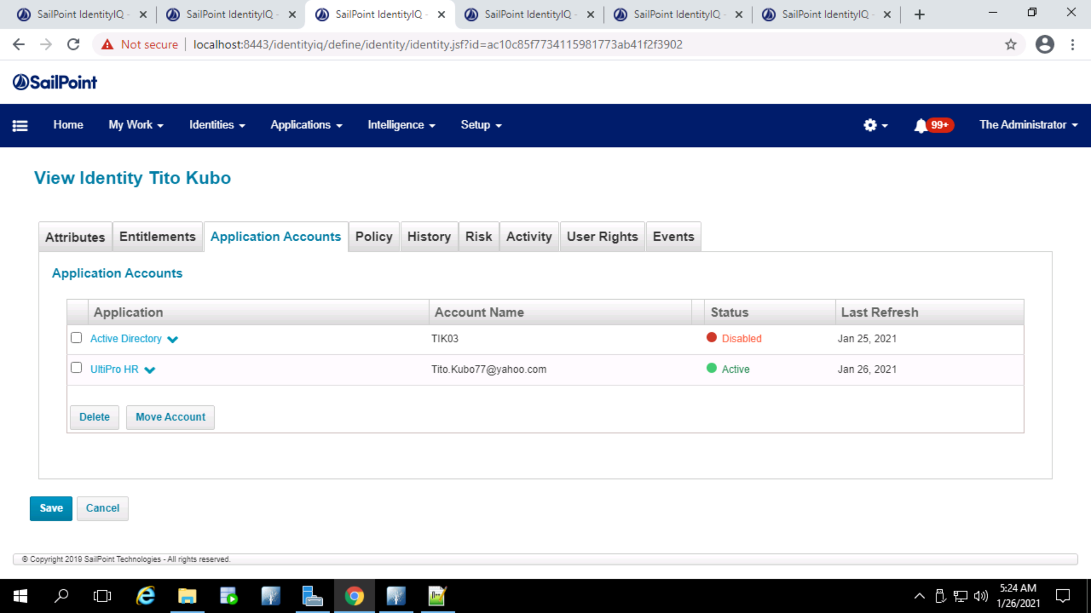

The AD account will get disabled for Furlough event.

The comment attribute in AD is set as ‘The user is in Furlough status’

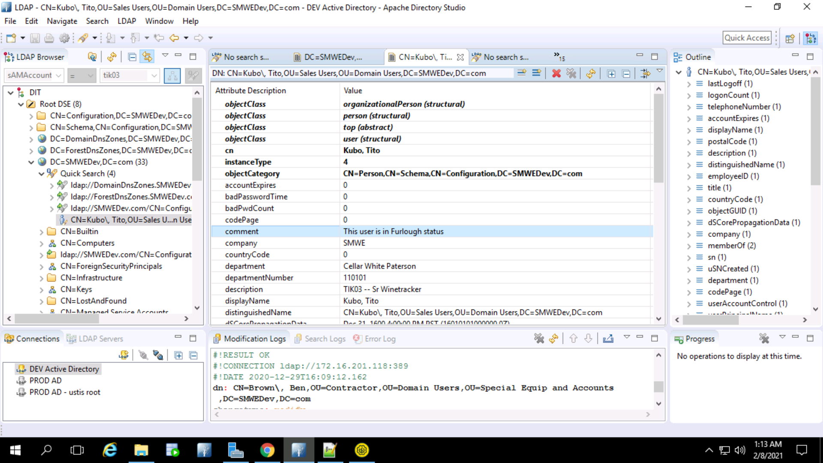

After 90 Days email will be triggered to the manager to take an action on the user if there is no action taken till 90 days.

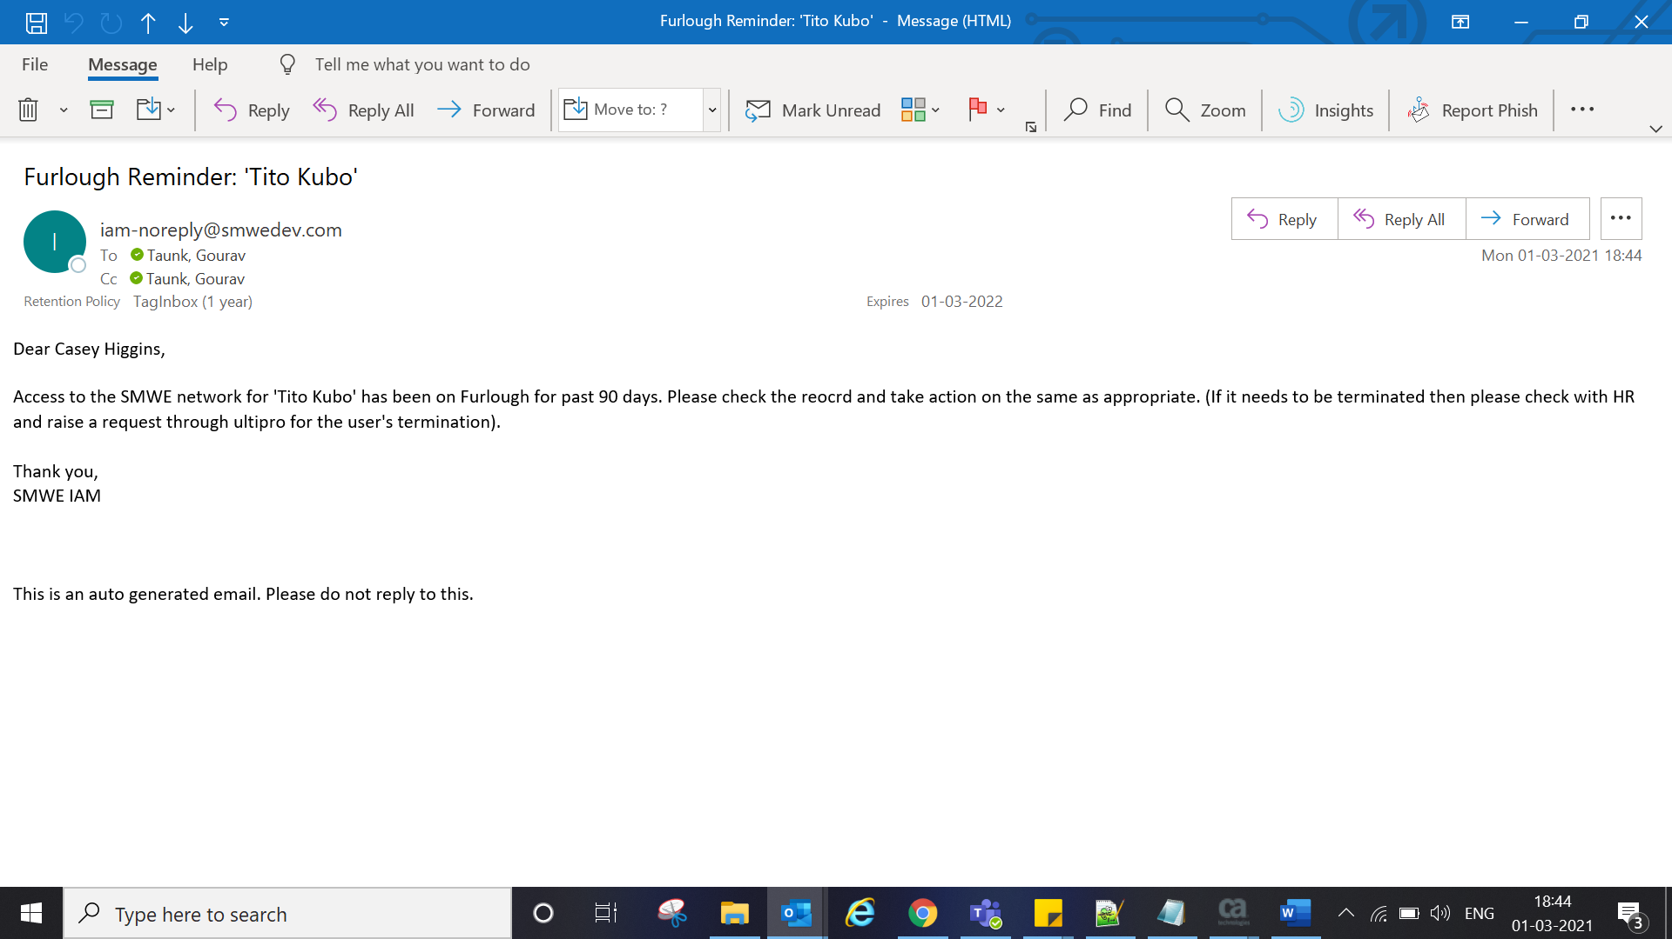



Furlough -> Active (Rehire)

The employee is in furlough state with every account disabled

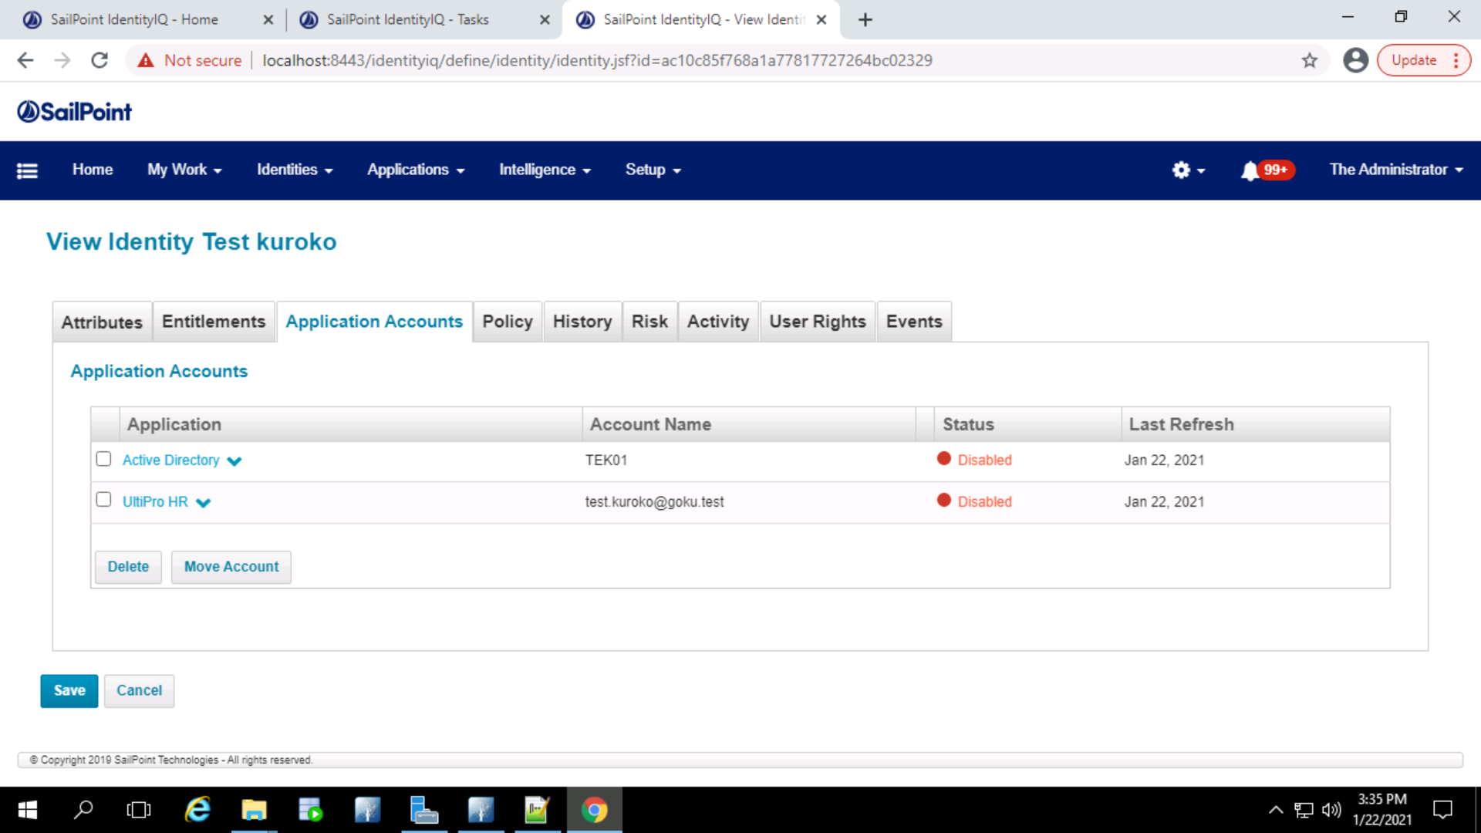

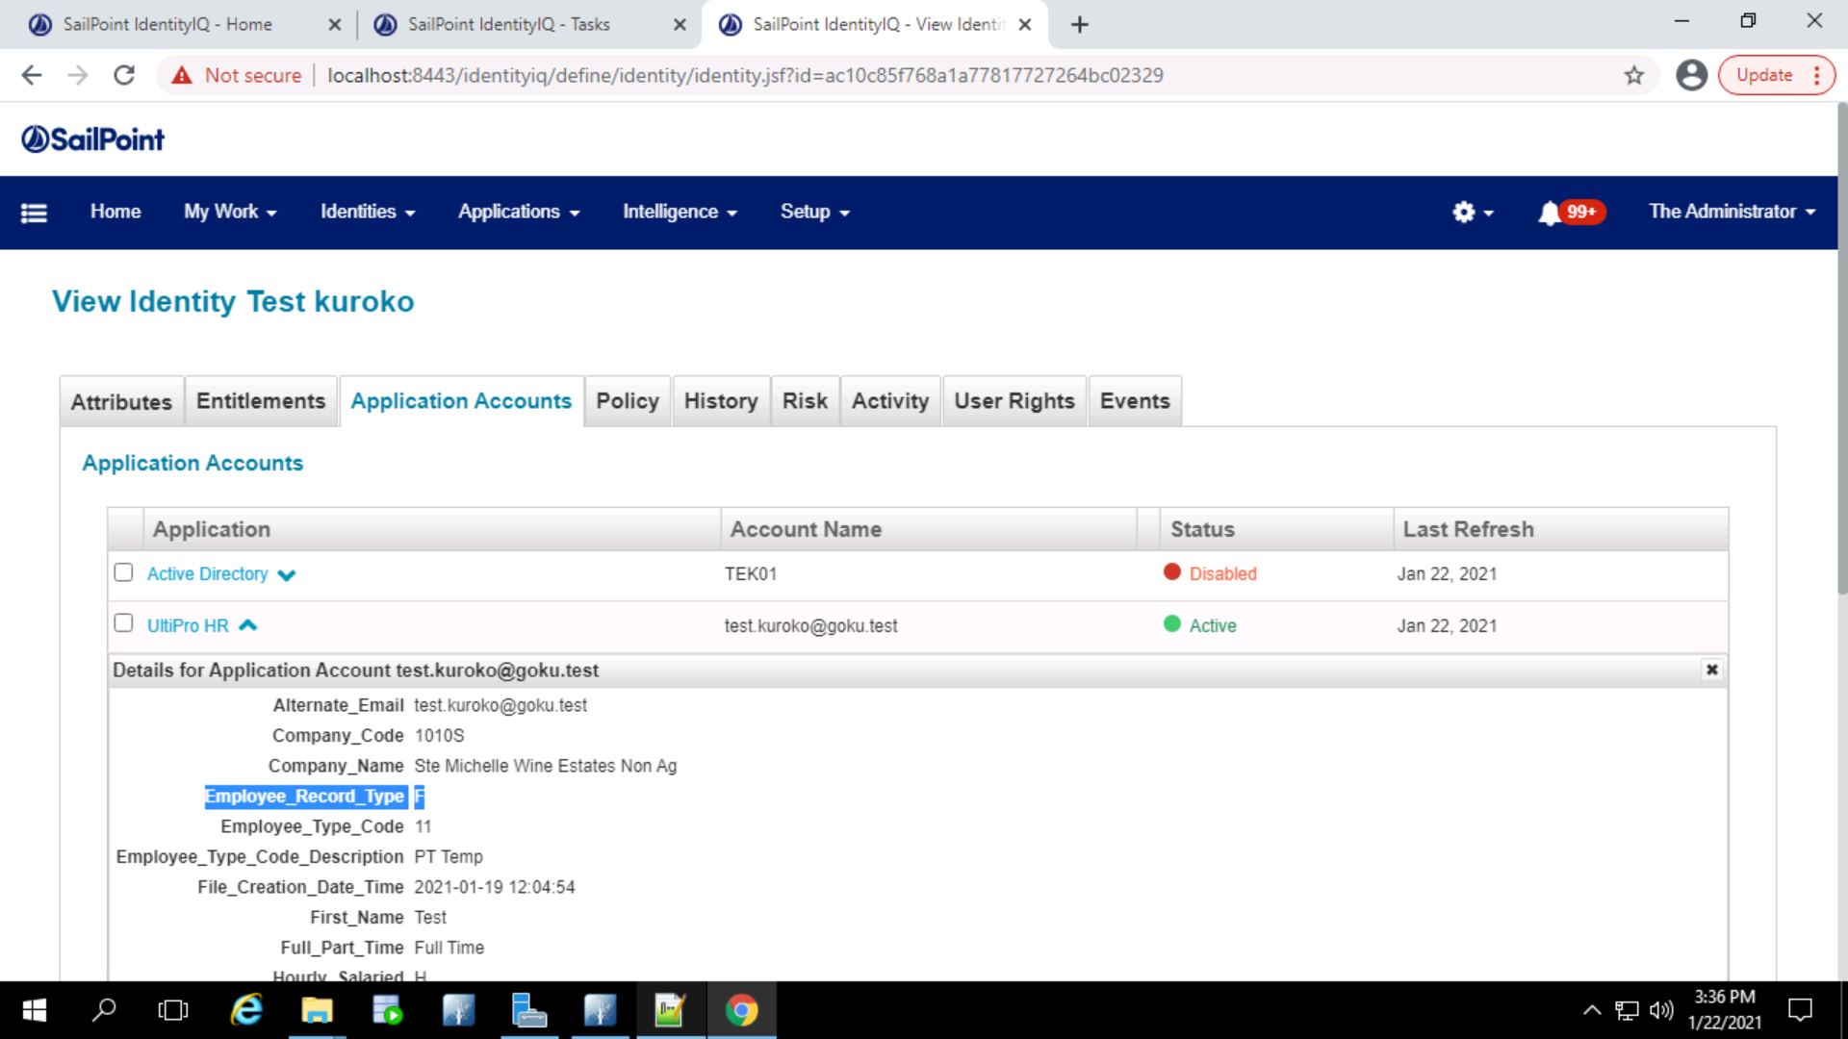

When the ultipro ‘Employee_Record_Type’ changes from ‘F’ (Furlough) to ‘A’ (Active), rehire gets triggered.

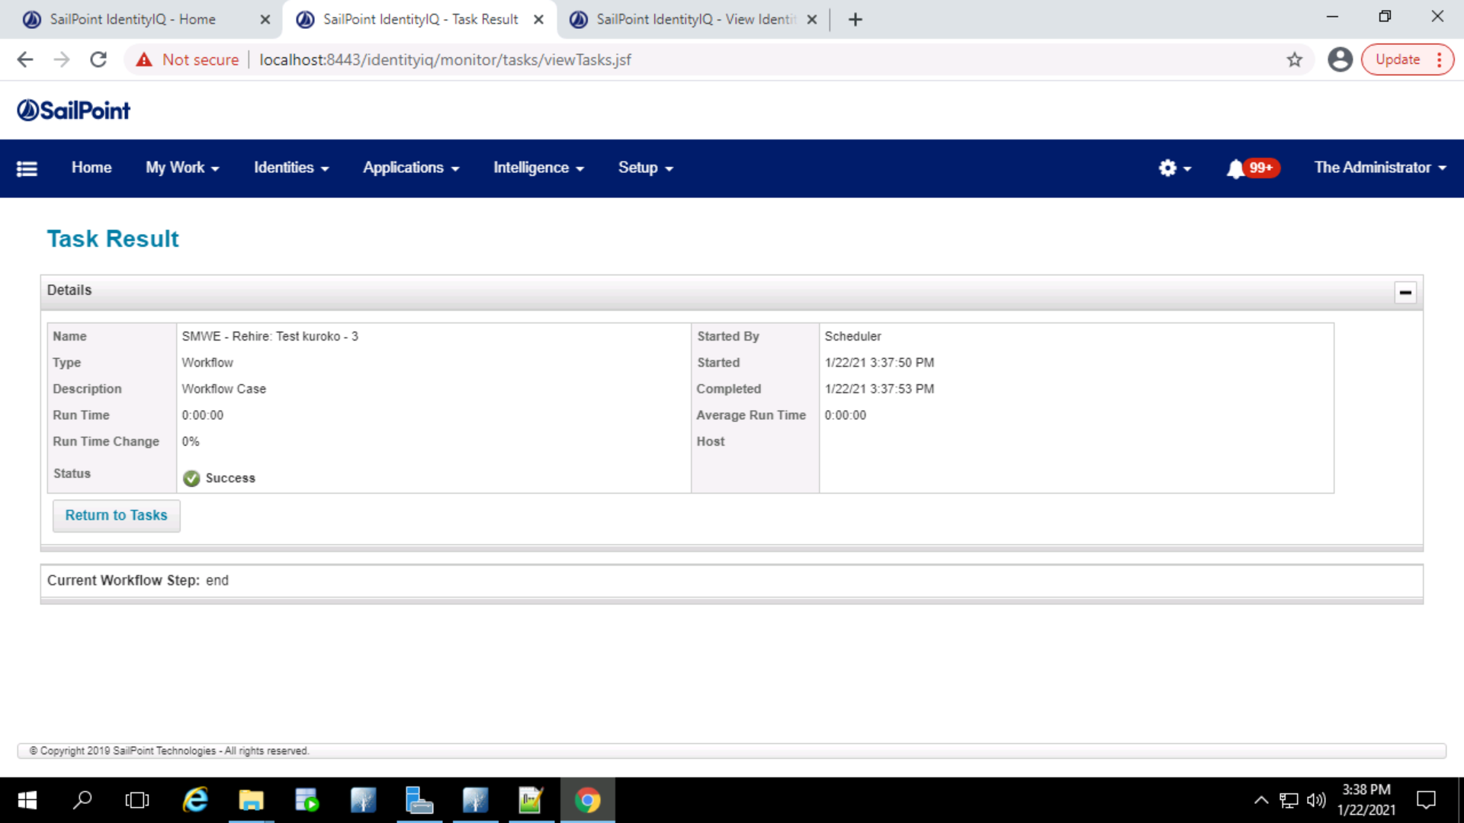

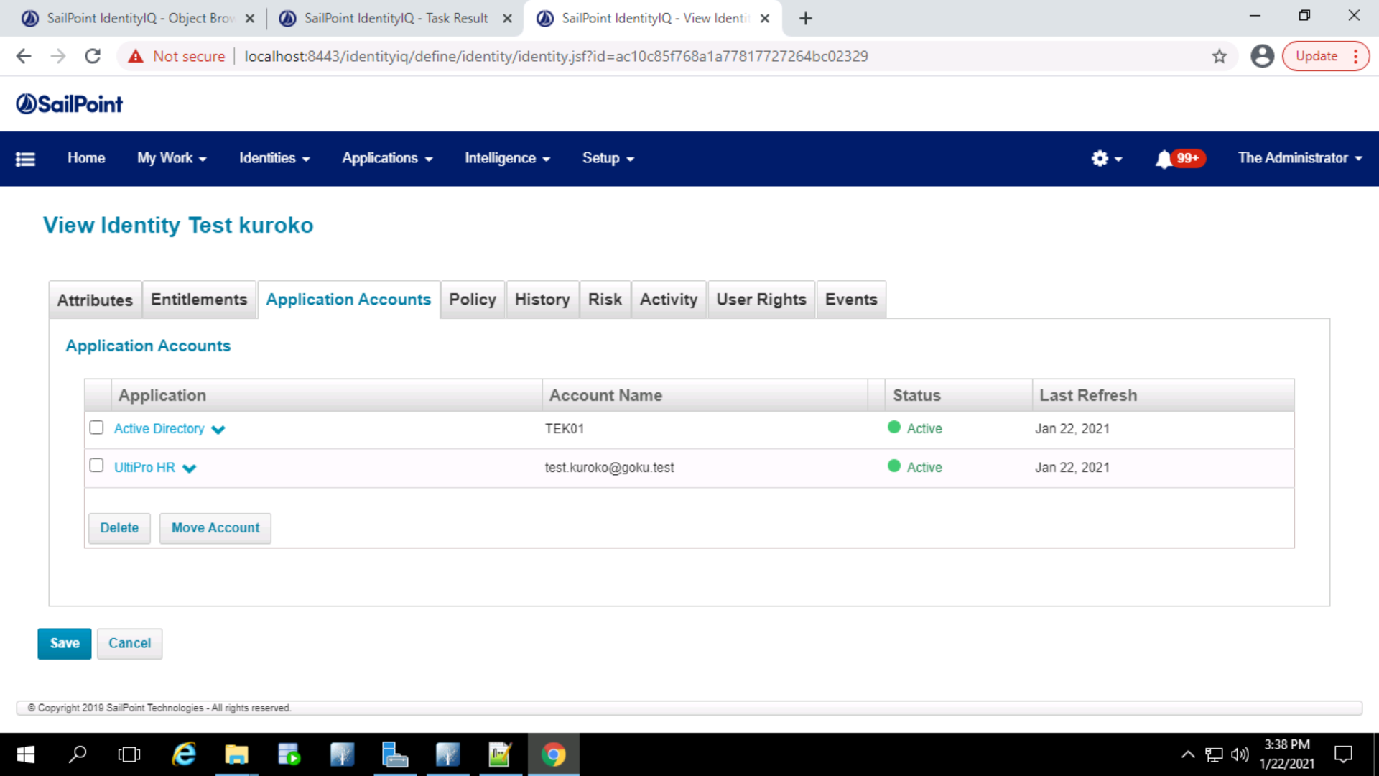

Rehire sends one email to the manager of the user with the password for the user in the emails.

